IPL Data Analysis

Data Information:

***Ball_By_Ball (1st CSV File):***

***Match_Id:***

Match Id gives us a idea in which how many bowls are bowled and how many wickets are been taken and what are the extra runs given in a specific match.

***Innings_Id:***

Innings Id defines that which team had batted first and which team has chased the score as only two different variables are there in whole column 1 and 2.

***Over_Id:***

As IPL is of 20 overs match so it will give the which over had given how many extras, runs, wickets etc.

***Ball_Id:***

Ball Id means an over i.e., gives us the data for each over ball from 1st ball to 6th ball.

***Team_Batting_Id:***

Team Batting Id is that each player had played how many bowls and respective to that what runs the played had scored.

***Team_Bowling_Id:***

Which bowler had bowled how many over.

***Striker_Id:***

Which batsman had scored a boundary i.e., 4 or 6 in a over.

***Striker_Batting_Position:***

As a batsman there are 1 down, 2 down etc. so it will inform which player had scored a boundary and what is his batting position in.

***Non_Striker_Id:***

The player which is standing at non striking end.

***Bowler_Id:***

The Id of bowler so that we can get all information about the respective bowler.

***Batsman_Scored:***

How much a batsman had scored on each ball.

***Extra_Type:***

As in cricket there are extra runs like wide, no ball, leg byes so it will inform on which ball what type of extras are given and if there is no extra then that column will be blank.

***Extra_Runs:***

How many runs been obtained through extras on each ball?

***Player_dissimal_Id:***

Which player is dismissed can be known with this column.

***Dissimal_Type:***

How a player is dismissed i.e., run out, bowled, leg by etc.

***Fielder_Id:***

If a player is dismissed by taking a catch, then that fielder information.

***Match (2nd CSV File):***

***Match_Id:***

Gives us which match is going on and who are the opponents and where is the venue.

***Match_Date:***

On which day the match was played.

***Team_Name_Id:***

Which team is playing on his home ground.

***Opponent_Team_Id:***

Who is the opponent of the home ground team.

***Season_Id:***

As the data is for 2008-2017 so there are 9 seasons so this column will give which season is going on.

***Venue_Name:***

In which city the match is been played.

***Toss_Winner_Id:***

Who is the toss winner the opponent team or the home team.

***Toss_Decision :***

What is the decision of toss head or tails?

***IS_Superover:***

If a match is tied then there is a need of super over so it will give information that the match has played a super over or not.

***IS_Result:***

Is the match result came or the match is abandoned due to some circumstances?

***Is_DuckWorthLewis:***

If a match is been shorten due to rain then duck Worth Lewis method is been implemented to get the result.

***Win_Type:***

How the win is been conquered I.e., by defending or by chasing?

***Won_By:***

By how many runs or by how many wickets the match is been won.

***Match_Winner_Id:***

Who is the winner of match.

***Man_Of_The_Match_Id:***

The player id who is man of the match.

***First_Umpire_Id:***

Three Umpire are there in the game out of which what is the id of the 1st Umpire.

***Second_Umpire_Id:***

What is the Id of the 2nd Umpire.

***City_Name:***

Venue city.

***Host_Country:***

Where the match is been planned.

***Player (3rd CSV File):***

***Player_Id:***

What is the id of the player and it will unique for all the players.

***Player_Name:***

What is the name of player.

***DOB:***

Date of birth for that player.

***Batting_Hand :***

Is the player left or right hand batsman.

***Bowling_Skill:***

How the bowler is bowling spin, pace, left-handed or right-hand bowler etc. skills are also been followed in this column.

***Country:***

To which country the player belongs to.

***Is_Umpire:***

*Is the player is also umpire along with playing the matches.*

***Player_Match (4th CSV File):***

***Match_Id:***

Which match a respective is playing.

***Player_Id:***

What is the player id so we can get which match a particular player is playing.

***Team_Id:***

Which team is playing can be obtained from this.

***Is_Keeper:***

The player who is playing is keeper or not.

***Is_Captain:***

The player who is playing is a team captain or not.

***Season (5th CSV File):***

***Season_Id:***

Defines the season number.

***Season_Year:***

In which year a respective season is been played.

***Orange_Cap_Id:***

The one with most runs in whole series get the orange cap.

***Purple_Cap_Id:***

The bowler who takes most wickets in whole season gets the purple cap.

***Man_of_the_Series_Id:***

The player who performs awesome with bat, ball and in field also get the man of the series award.

***Team (6th CSV File):***

***Team_Id:***

What is the team id which will be unique for all the teams.

***Team_Name:***

What is the full name of the team.

***Team_Short_Code:***

Short name for the teams.

***Dismissal type:***

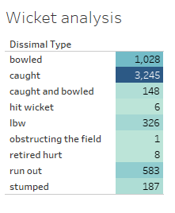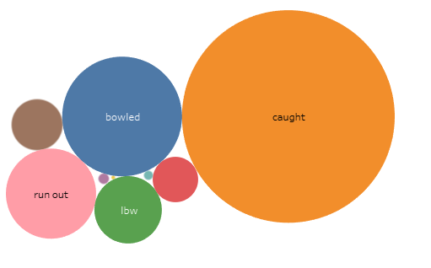

* Here we can observe that most the wicket which are been fallen are caught and after that the dismissal type is bowled.
* Other type of dismissals is also there but there are not that much wickets fallen in that type.

***Left Hand vs Right Hand:***

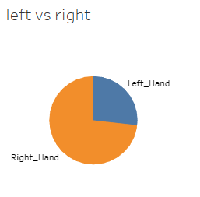 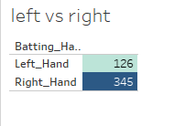

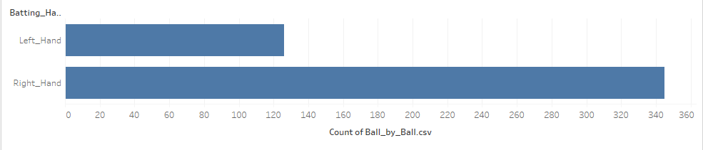

***Observation:***

* The above three graphs represent the difference of left-hand batsman vs right- hand batsman.
* So here we can conclude that most of the player i.e., around 65% to 70% players are right-hand batsman and the remaining are the left-hand batsman.

***Bowling vs Batting Skill:***

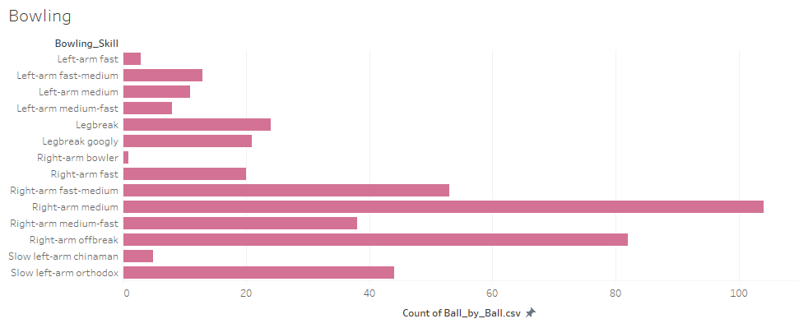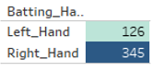 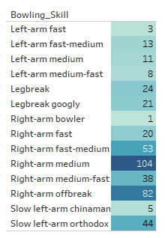

***Observation:***

* As IPL is a 20 over there should a nice pace and swing bowlers attack to tackle the batting team and so we can see in the graph 104 are right-arm medium i.e., swing bowlers attack.
* Then Right-arm off break bowlers also play an important role in the bowling unit.

***Batsman side with respect to their country:***

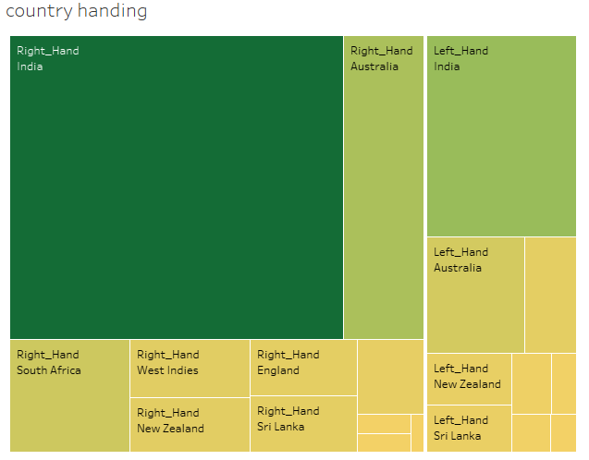

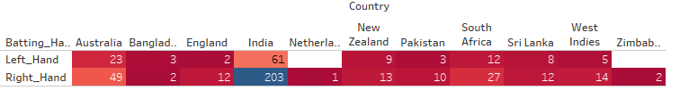

***Observation:***

* As IPL is a Indian league most of the players will be of India origin and clearly we can depict from the graph the 203 players are Indian Right hand batsman and 61 batsman are left hand batsman.
* After India the most popular players of Australia comes in picture.

***Toss vs Win Type:***

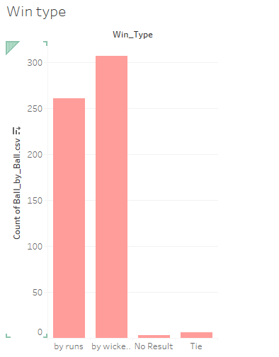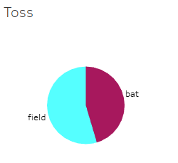



***Observation:***

* Around 60% of the team who has won the toss had choose to field and this result is also reflected in the winning rate also. The team which chooses to chase had won more matches as compared to the teams who defend it.
* So, the team with the nice bowing attack and if they choose to bowl then there is high probability of them to win the match.

***Venue and Host Country:***

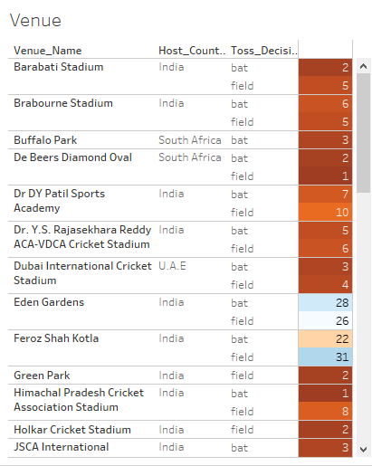

***Observation:***

* In above report we get the detailed information about the venue and toss information as well as how many matches are been played in a stadium can also be analyzed through this.
* We can see that 2 stadiums 1. Eden Gardens 2. Feroz Shah Kotla in India has largest number of played matches.

***Venue vs Winning:***

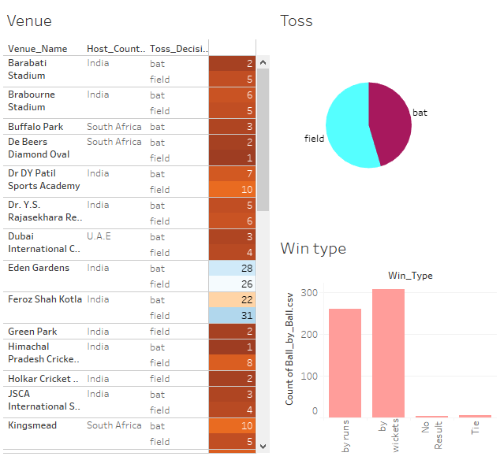

***Observation:***

* We can get all the information about how many matches are been organized what is the probability of winning the toss what is the probability of winning the match by runs or by wickets or due to some problem there is no match result.

***Drill Down Report:***

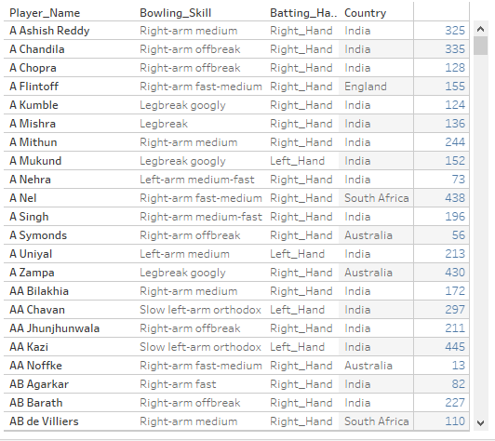

***Observation:***

* In above report we had taken the player information i.e., his playing skills.
* We can clearly get all the necessary playing information about a player like its bowling action from which side the player is batting and what is the id of that player.
* This information can be important for a franchise for buying or selling the player to make a team stronger.
* Here we also get the information which player are foreigners and which player are Indian so that purchase can be made according to that.

***Total Matches played per year:***

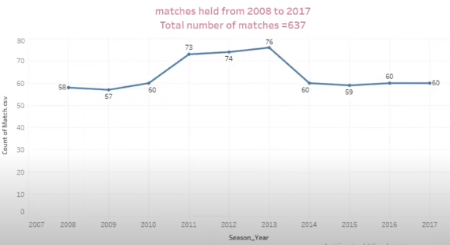

***Observation:***

* Here we can analyze that total 637 matches are been played and in 2013 highest 76 matches are been and following that in 2011, 73 matches were played.

***Purple cap, Orange cap and MOM Distribution:***

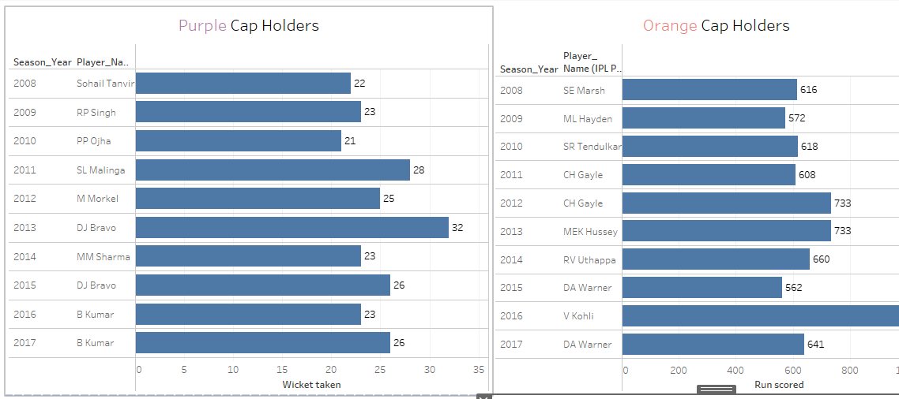 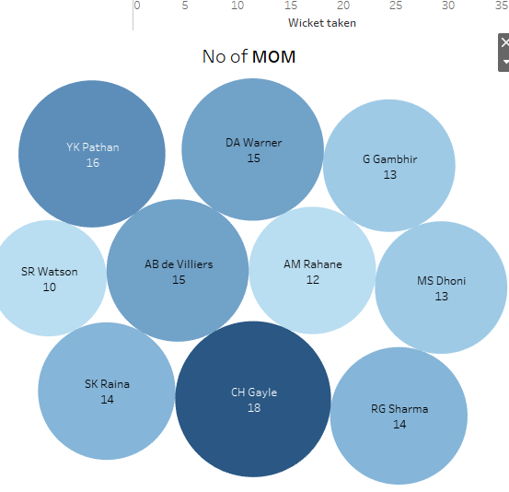

***Observation:***

* Purple cap holders i.e., for the highest wicket for respective years are been shown.
* Orange cap holders i.e., the highest run getters are shown.
* Man of the Match the i.e., the best performer of a match.

***Number of Wrong Decision taken by respective umpires:***

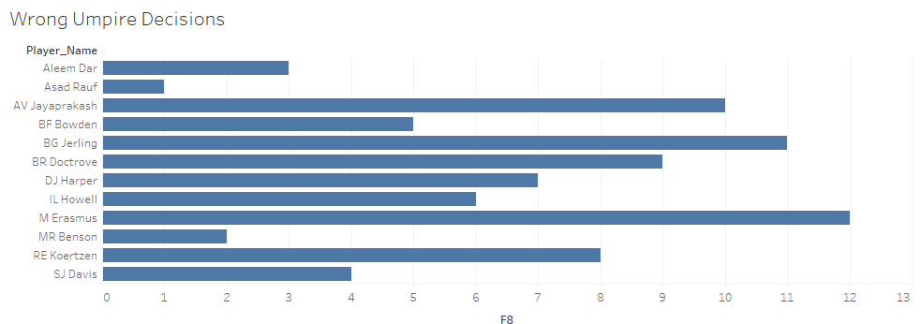

***Observation:***

* Most number of wrong decisions were taken by M Erasmus.

***Number of Matches won:***

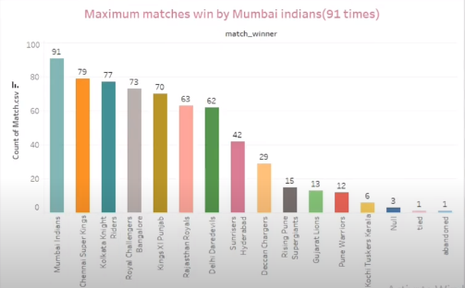

* We can see that most number of matches were won by Mumbai Indians and that are 91 matches so we can say the MI is most successful team of IPL.

***Player Figures:***

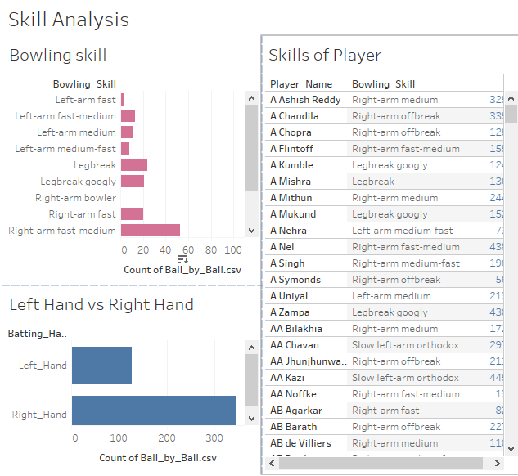

* All player information can be obtained from this dashboard as we can get their and other information also from this dashboard.

***Venue vs Duck Worth Luis:***

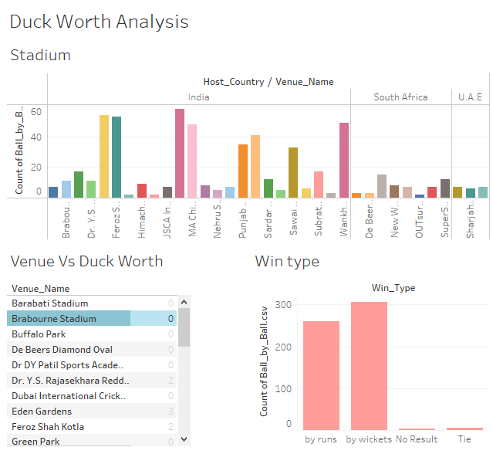

***Observation:***

* It gives an idea about in which stadium the Duck Worth Luis method is been followed and the result is obtained and what is the percentage of winning is also been shown here.

***Team Performance:***

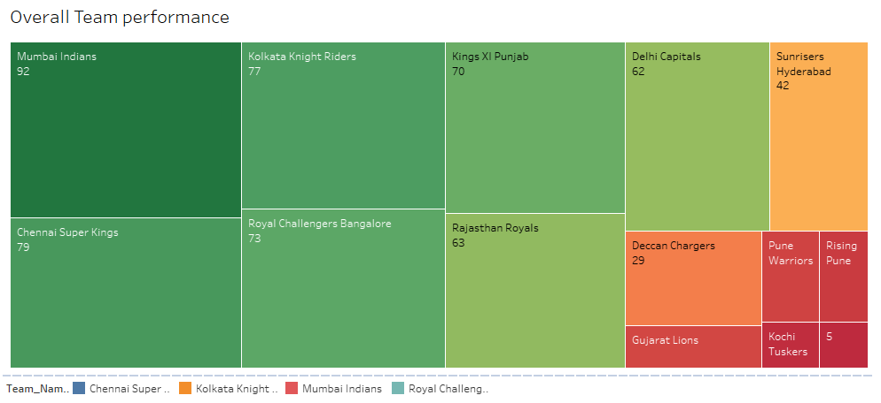

***Observation:***

* As we can see most successful team is MI and according to the graph the MI has the increasing graph and the most disappointed performance is of RCB as we can see that RCB is decreasing.

***Venue and Toss Analysis:***

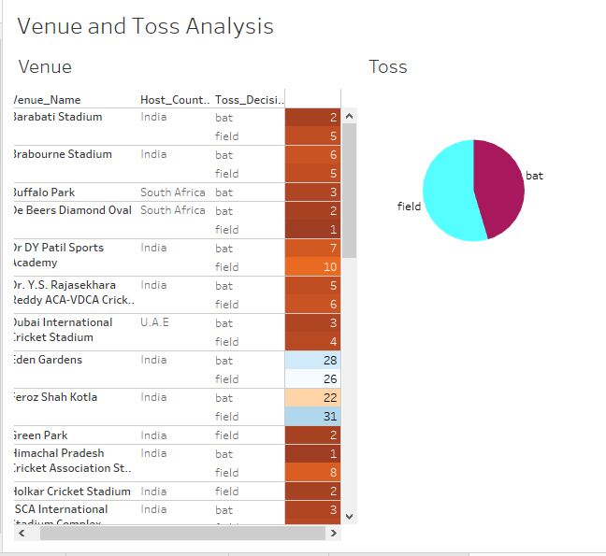

* Here we can get the prediction of winning percentage who the team who has batted first got the win or the team who bowled first.
* This all information is there for all the grounds respectively.

***Win Vs Skills:***

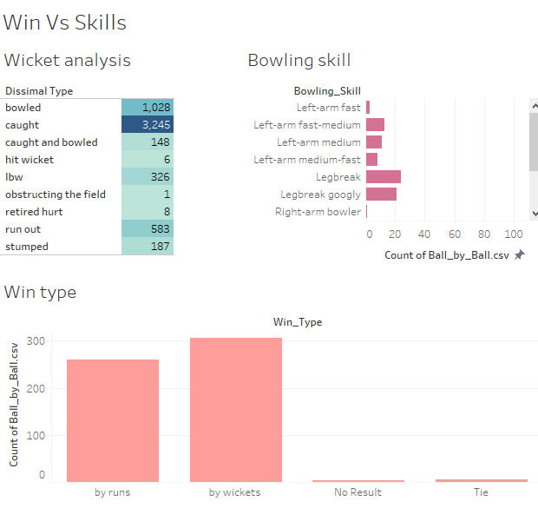

***Observation:***

* The team with the all set of skills will win more matches and also had a chance of winning the title also.
* Here the fielders play an crucial role as we can see the wickets are got more from the catch only.

***Winner Analysis:***

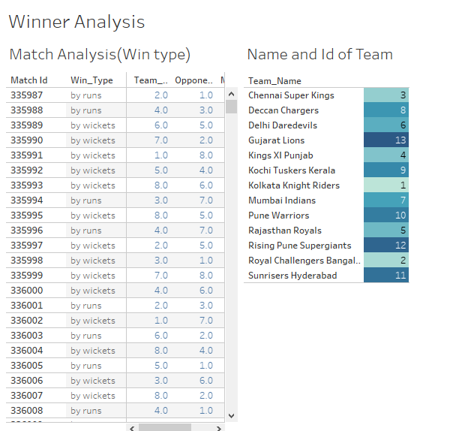

***Observation:***

* Here from this dashboard, we can analyze each match and can by which team the man has been won who was the opponent does the win was by chasing or defending and who is man of the match.
* Such type of information can be important for the future matches.

***Team Matches:***

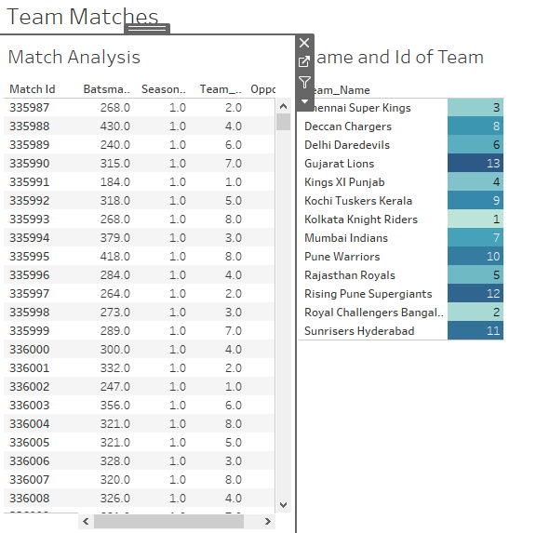

***Observation:***

* From this dashboard we can get how many total runs are been scored in a match and who we the opponents and in which season the match is been played.

***Stadium Vs Match Analysis:***

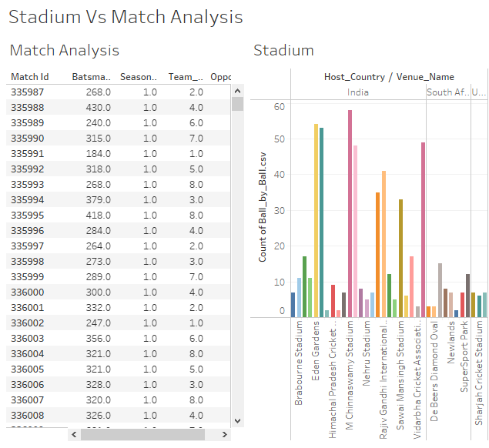

***Observation:***

* Where the match is been played how many matches are been played at a venue, how many runs are been scored in a match and who are the two teams that are playing the match against each other this all information can be get through this dashboard.

***Skills And Birth Country:***

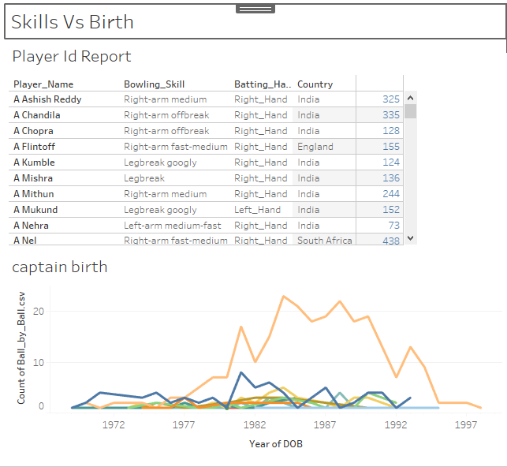

***Observation:***

* The yellow line which is highest is of India as the IPL is a Indian origin league so most of the players are from India and most of them are been born in the phase of 1985 to 1988.

***Umpire and Venue Analysis:***

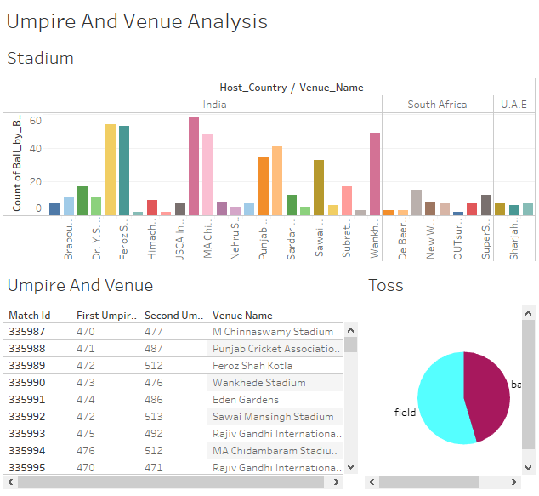

***Observation:***

* Which city is hosting which match who are the 2 umpires of that match respectively and what is the name of stadium. After winning toss what is been chosen by the team can be seen in this dashboard.